How to push a file in github

Step 1: Create a folder name called push

Step 2: Open the folder and copy the folder name and paste it on the command prompt

Step3: Open the command prompt and type cd and give some space and paste the new folder url and press enter

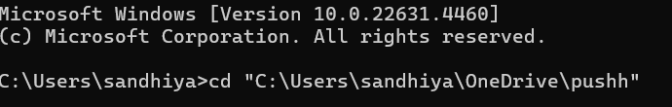

Step4: create a new repository in github and paste the first three lines and press enter



Step4 : Type git add . and paste the url of next four lines and press enter